Distance vs Grade

We tested if the distance from London affects the grades the REF gives an institution, as in England London, and the area near and around London, is known to have the most “Prestigious” universities, e.g. Cambridge, Oxford and Imperial College London are all within 85km of London (reference google maps here pls). This was tested in two ways, firstly with a correlation test between the distance in kilometres from London and the mean percentage of 4* grades per institution. The second method tested whether if there was any significant difference in the mean % of 4* grades if the institutions were grouped by distance.

To test for a correlation between the distance institution is from London and the percentage of 4* grades given by the REF, the distance from London for each institution was first of all found out using an online distance calculator (use this as a source I guess? <https://www.daftlogic.com/projects-advanced-google-maps-distance-calculator.htm>) and then a spearman’s rank correlation test was ran, which gave a result of

rs=-0.2088194, p=0.00935.

Which gives evidence for a weak negative correlation between the grade the REF gave an institution and it’s distance from London. (In discussion mention that this is weak and as such doesn’t give much sway to the argument, unless there are sources that back this up?)

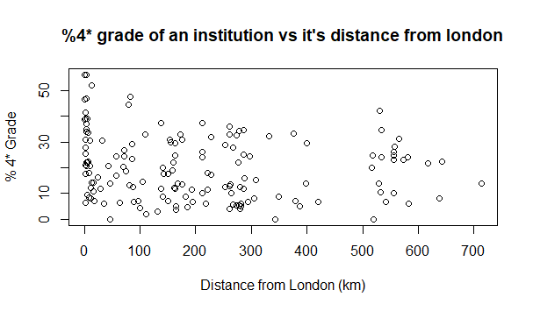

(This figure is called DistvsGrade)

A further test was ran to see if there was any significant difference between the 4* grades given if the data was grouped by distance. This gave a value of H=19.384, p=0.003562, giving strong evidence to support the idea of there being a difference between the 4* grades of the grouped distances.

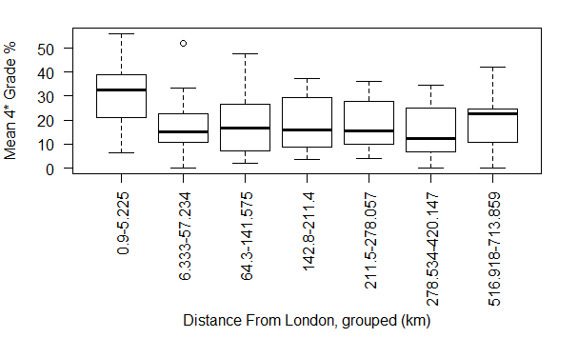

(This figure is called DistancevGroup)

Group type vs Grade

A difference test was also ran between the grades of the institutes that were classed as “Russell Group” and those who were not classed as such. This was to see if there could be a possibility of bias from the judging panel, as universities who are classed as “Russell Group” are considered to be better than those who are not.

A mann-whitney U test was ran between the two groups, the results of which can be seen in the table below

|  |  |  |  |  |
| --- | --- | --- | --- | --- |
| Grade | W Score | P value | Russell Mean | Non-Russell Mean |
| 4* | 137860 | < 2.2e-16 | 34.24288 | 16.66318 |
| 3* | 331630 | 4.412e-13 | 47.62969 | 42.23875 |
| 2* | 687050 | < 2.2e-16 | 16.17391 | 31.67685 |
| 1* | 622240 | < 2.2e-16 | 1.661169 | 8.135048 |
| Unclassified | 481990 | 1.767e-13 | 0.2923538 | 1.286174 |

All of the mann-whitney tests gave strong evidence towards there being a significant difference in the mean % of each grade, with the Russell groups showing a higher mean % of 4* grades, and a lower mean % of all the other grades, when compared to the non-russell groups. (in discussion mention how this could either indicate bias, or that Russell groups are indeed as good as they are meant to be)

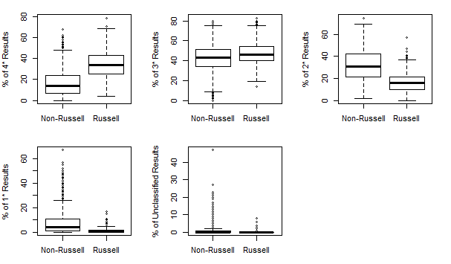

(this figure is called russel vs non)